***SPEEDIFY***

**Members:**

* Hashim Khan
* Hannan Fareed
* Tayyab Irfan

***Graphical User Interface (GUI)***

1. **Page 1**

*welcomePage:*

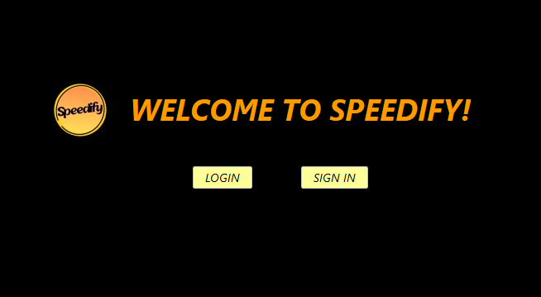

*User will be asked to either log in or sign Up. If the user clicks on on login button, a loginPage will be directed.*

1. **Page 2**

*loginPage:*

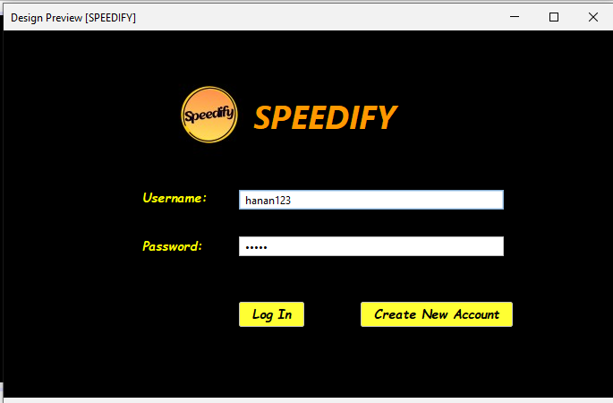

*If the account is not registered before, user will be asked to create an account first by clicking on Create new Account which will direct him to a signUpPage.*

1. **Page 3**

*signUpPage:*

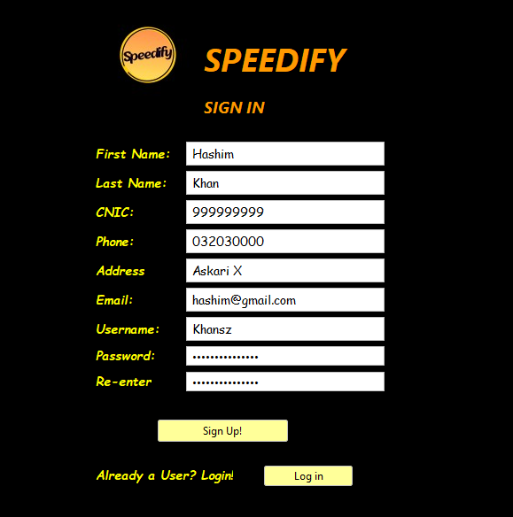

*And now when the account is successfully registered and logged in , user will be directed towards a new page called homePage.*

1. **Page 4**

*homePage:*

*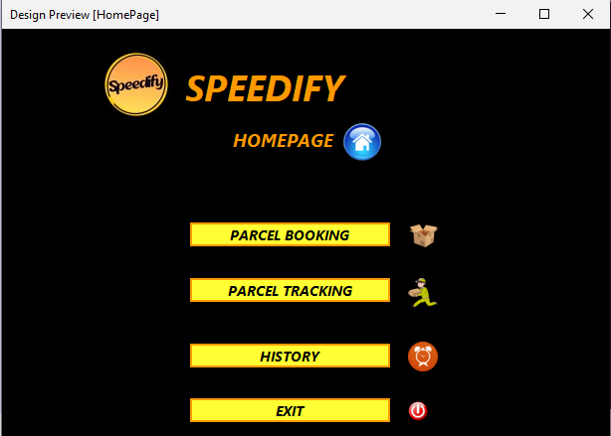homePage will direct users to his choice according to the buttons pressed, but before coming on to that, there are some additional options for users with respect to its account such as viewing profile and update profile.*

1. **Page 5**

*profilePage:*

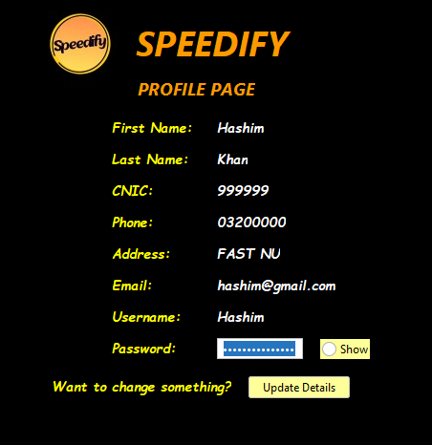

*This can help user view his or her profile and additionally, if any kind of changing is required, the button “Update Details” can be easily triggered for updation where updateProfile page would be made active.*

1. **Page 6**

*updatePage:*

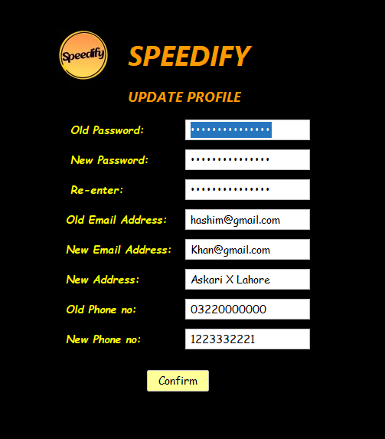

*After any updation, the homepage options will be asked from user whether parcel booking or tracing is to be triggered.*

1. **Page 7**

*parcelBooking:*

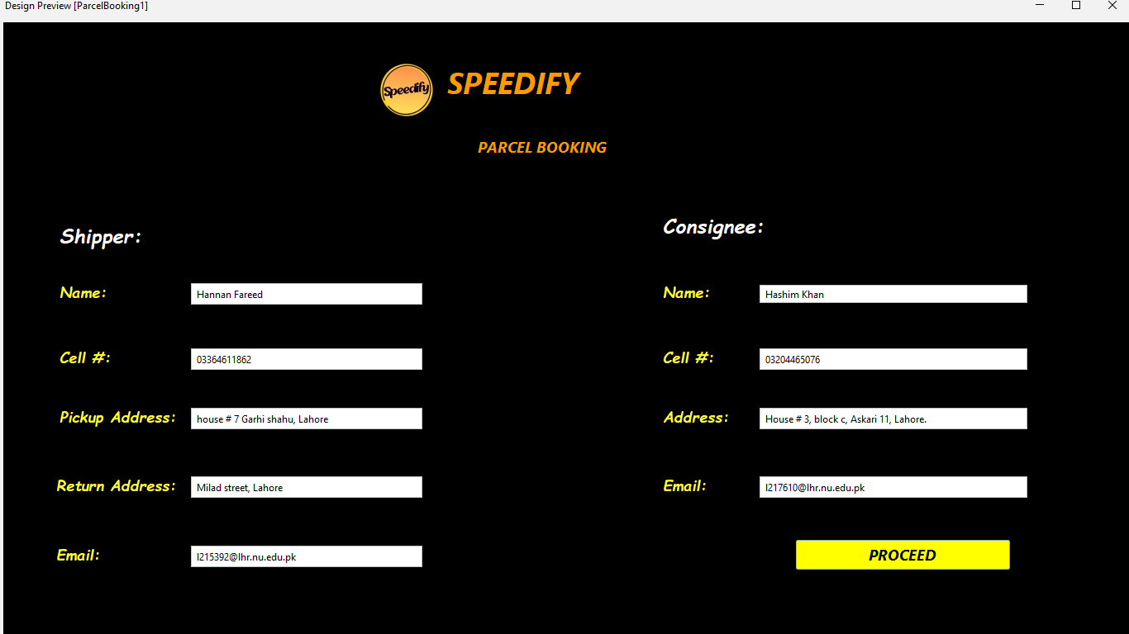

*After giving all the details of shipper and consinee, user will be asked about the consignments like this:*

1. **Page 8**

*parcelBooking2:*

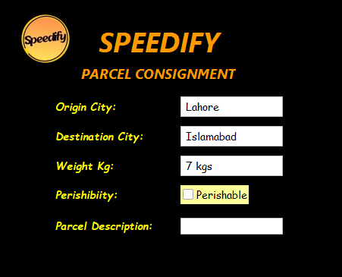

*Now consider that the parcel is completely booked successfully, the user is conditioned to add paymentDetails.*

1. **Page 9**

*paymentOptions:*

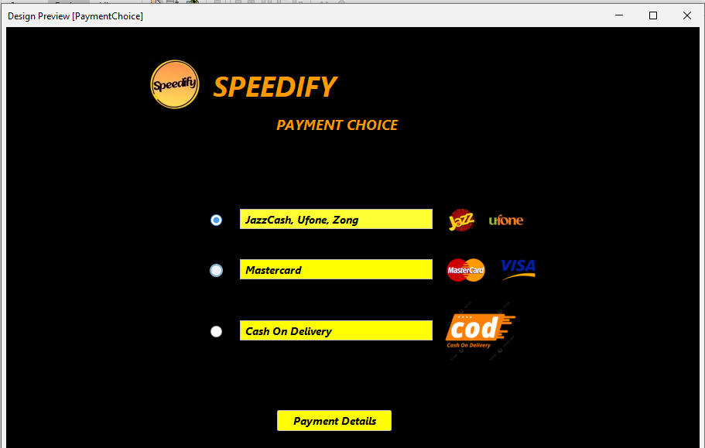

*If the user selects card options, page paymentChoice2 will be directed, else paymentChoice1 for sim unless he has not selected Cash on Delivery option. There is no separate page for Cash on Delivery because all of the information, details of customer is already fed on previous pages.*

1. **Page 10**

*paymentChoice1:*

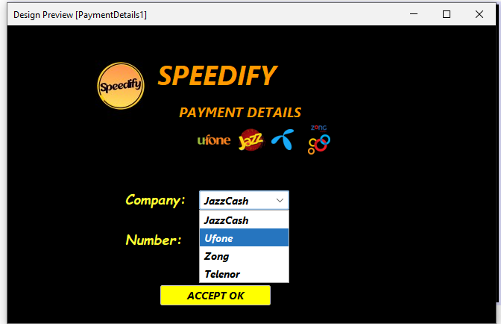

*After selecting the company name, number will be filled.*

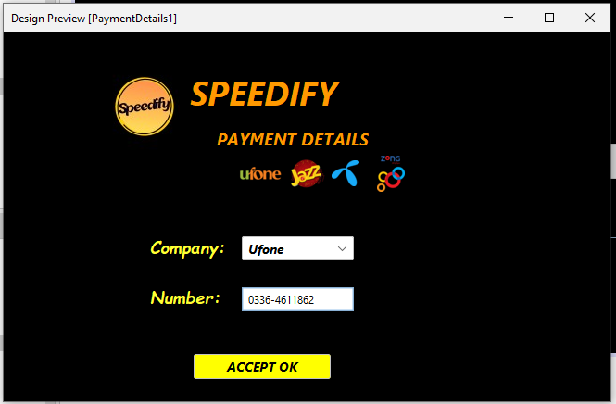

*Now, let’s suppose that this option for paymentOption page was not selected, the option that was selected was card method. Page paymentChoice2 will be directed.*

1. **Page 11**

*paymentChoice2:*

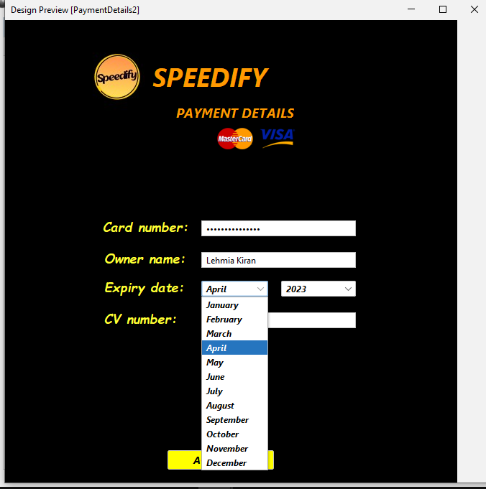

*After selecting month from the drop down menu, year will be selected from dropdown menu.*

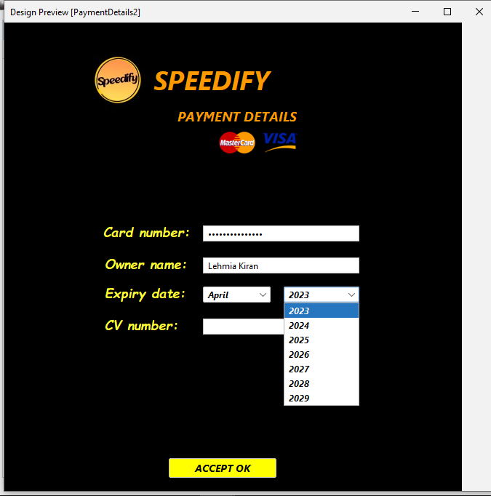

*After the selection of year, card payment method will be verified and proceeded towards online payment successfully.*

*Final GUI of card payment method will look like this:*

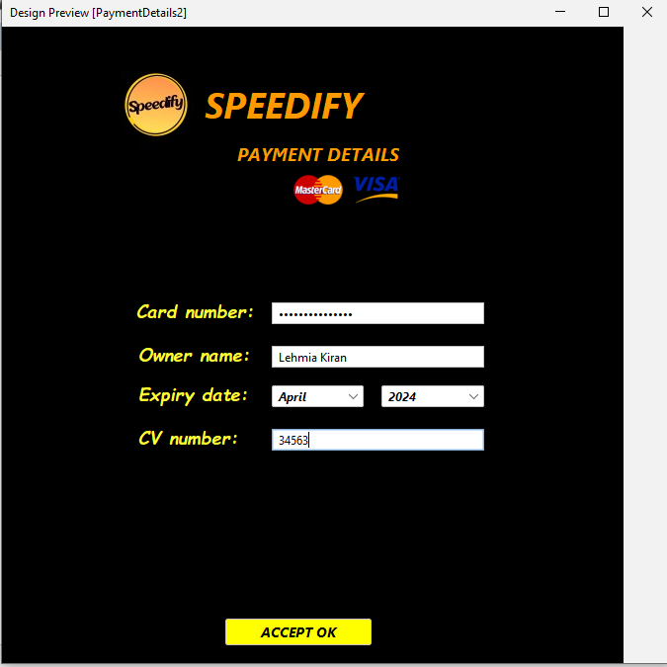

1. **Page 12**

*parcelTracking:*

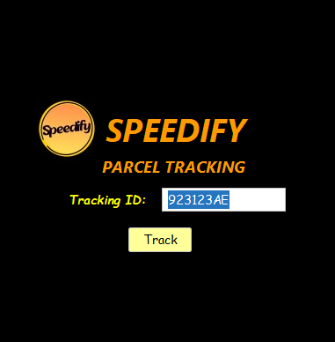

*The tracking page will ask for a unique parcel id to check for its delivery status and tracking. The track button will trigger its location and status as:*

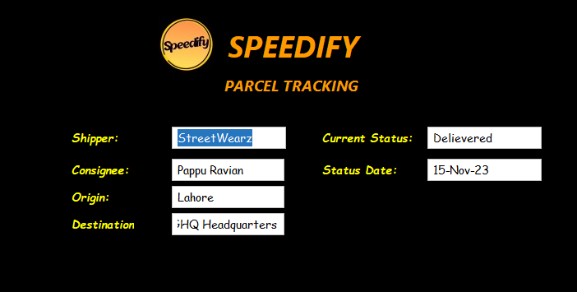

*After parcel tracking, cart will be displayed at the end.*

1. **Page 13**

*Cart:*

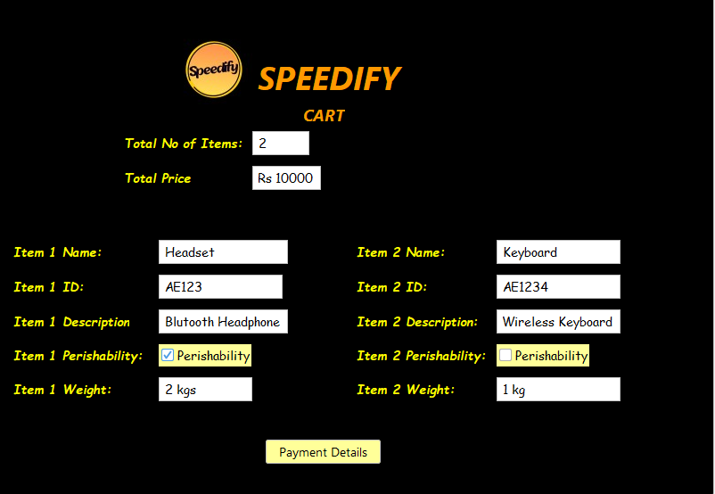

*Total parcels booked and their id and all the expenses will be shown.*